《信息管理系统开发实践》

报 告 书

系 部：计算机技术系

专    业：计算计科学

课题名称：论坛信息管理系统

班    级：网络 91761

学    号：9999176132

姓    名：HAZIM BIN SHAIFUL BAHARI 何子铭

指导教师：黄可望

无锡职业技术学院

软件技术系

2019 年 5 月 19 日

目录

1. Task 1

2. Project Description 4

3. Reflection 30

4. References 31

# Task

**信息管理系统开发实践**任务书

系部计算机技术系 班级网络 91761学号9999176132 姓名 何子铭

一、题目：

二、目的要求：

1．通过实践培养学生信息管理系统开发的能力。

2．掌握计算机应用中理论和实践的关系、设计计算机应用课题的思想和方法。

3．通过实践培养学生查阅和分析、整理资料的能力、课题调查、获取资料的能力。

4．培养学生选择相应的数据库管理系统，锻炼学生分析和创建数据库的能力。

5．培养学生具有综合运用所学的计算机基础知识、专业知识，去分析和解决计算机应用过程中实际问题的能力，培养创新思维。

6．培养学生方案设计、编码设计、实验调试的能力和编写设计文档（包括论文、使用说明书等）的能力

7．培养学生在遵守纪律、掌握进度、思维独立等非认知因素方面具备能力。

三、设计内容：

1．确定课题，进行项目描述与项目设计

根据下达的设计任务书，在分析有关资料基础上，确定课题及开发技术，提出初步方案；到相关部门调研、到图书馆或网上查阅资料，写出需求分析。根据需求分析进行系统分析，设计功能模块图，确定所需数据表与数据结构。

课题选择要求：

（1）学生可选择教师公布的课题，也可以自选课题；

（2）每位同学单独做一个课题。

2．项目实施

根据设计要求使用主流软件进行系统开发，体现良好设计思想，代码编写规范，界面统一，配色美观大方，发布并运行程序，制定测试计划，对软件项目进行较全面的测试，对出现的问题进行修改和完善并逐步形成进度推进和质量保证的思想。

3．项目维护

发布并运行程序，编写出说明书。

4．写出专用周报告书

报告书要包含从1~3部分的说明文档（包括系统概述、系统分析、系统设计、系统测试和使用说明）、小结及参考文献（要求全部打印）。

5．准备检查。

四、进度

每个进度的时间要求如下表。

表1：《信息管理系统开发实践》课程学时分配表

|  |  |  |  |  |
| --- | --- | --- | --- | --- |
| 序号 | 课程内容 | 课 程 分 配（周） | | |
| 讲解 | 设计或其它 | 合计 |
| 1 | 论文动员、指导教师下达任务书 | 0.2 | 0.8 | 1 |
| 2 | 课题调研，写出开题报告 |  | 1 | 1 |
| 3 | 方案选择、系统性能分析 |  | 1 | 1 |
| 4 | 编码设计或方案具体设计、实验调试 |  | 4 | 4 |
| 5 | 撰写各类文档说明书及论文 |  | 1 | 1 |
| 6 | 送审，指导教师评定成绩 |  | 1 | 1 |
| 7 | 毕业答辩、评定综合成绩 |  | 1 | 1 |
| 总计 | | 0.2 | 9.8 | 10 |

五、评价形式

出勤与课堂表现、项目检查、实训报告等。

六、评分标准

表2：评分结构表

|  |  |  |
| --- | --- | --- |
| 序 号 | 成绩比例（％） | |
| 1 | 指导老师评定成绩 | 40 |
| 2 | 评阅老师评定成绩 | 30 |
| 3 | 答辩成绩 | 30 |
| 总评成绩 | | 100 |

**开始日期： 2019 年 月 日 完成日期：2019 年 月 日**

**指导老师： 黄可望**

# Project Description

## 2.1网站概述及开发工具

### 2.1.1 Website Overview

“TalkNPost” is a website I developed to help a person share their thoughts throughout the globe. If you ever heard of reddit.com, my idea is loosely based on that website. Whenever you have a topic in mind and seek discussion, my website allows you to upload your content and begin interacting with one another. People are able to view your content and leave a comment and subsequently you may also reply to those comments. People can also come and rate your content from 0-100 and the highest score content will appear in the home page under most popular. My main target is to make every person’s voice heard around the world and every single soul has the same opportunity to do so.

### Development Tools

#### Microsoft Visual, (MV) (ASP.NET)

I was first introduced to this software back when I was in semester three where I have C# class. Back then we only use this tool to develop web application and I never once thought that it can also be used to develop a fully functioning website. Using this allows the website to be connected to database as well as to use all the control tools such as Textbox, Gridview, Datasource and many more uncountable useful tools. This in return helped immensely in developing my website and making it a reality.

#### SQL Server Management Studio, (SQL)

Back when I was studying C#, my go to database is Microsoft Access, (MA) because I thought only this database can be connected to MV. However, in this semester ASP.NET class, which coincidentally also uses MV, we learnt that MV also supports SQL. This prove to be useful because in our database class, we use SQL to familiarize ourselves with database functionality so we are very comfortable using it. SQL is friendly to use and easy to navigate because it has its own GUI and we can choose to create our tables either using query command or SSMS.

## 2.2网站分析

### 2.2.1 Requirement Analysis

Wanting to share your thoughts is a basic human instinct to pass down your knowledge to your successor. It began from the dawn of time and some might even argue it is encoded in our DNA. It also evolves through the flow of time. Also, to keep up with current event of the globe, it used to be through the spreading over newspapers. Now, at the current state of technology, we can get any info directly from the comfort of our home. That is why I envisioned my website’s purpose. To make unheard voice able to touch the ears of every living soul. We can share information regarding politics. For example, who is the current president of a specific country? Or even entertainment wise such as how the latest movie is received by its audience? Or even educational. For example, the usage of a specific formula when solving a problem whether in mathematics or even chemistry.

### 2.2.2 Functional Analysis

（1）No Account

1）Dashboard

1）Home

2) Browse

3）Login

4) Register

5) Search

2）Body

1）Most Searched

2) Recent Post

3）Category

（2）Standard Account (Only can see standard contents)

1）Dashboard

1）Home

2) Browse

3）Profile

4) Create

5) Search

6) Update content

7) Logout

2）Body

1）Most Searched

2) Recent Post

3）Category

（3）Premium Account (Can see all contents)

1）Dashboard

1）Home

2) Browse

3）Profile

4) Create

5) Search

6) Update content

7) Logout

2）Body

1）Most Searched

2) Recent Post

3）Category

### 2.2.3 Function Module Design

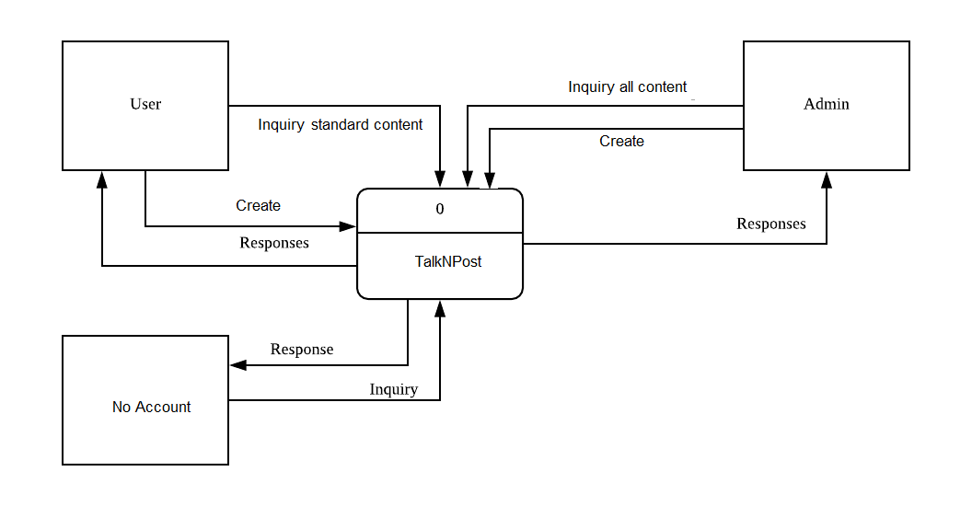

**Context Diagram**

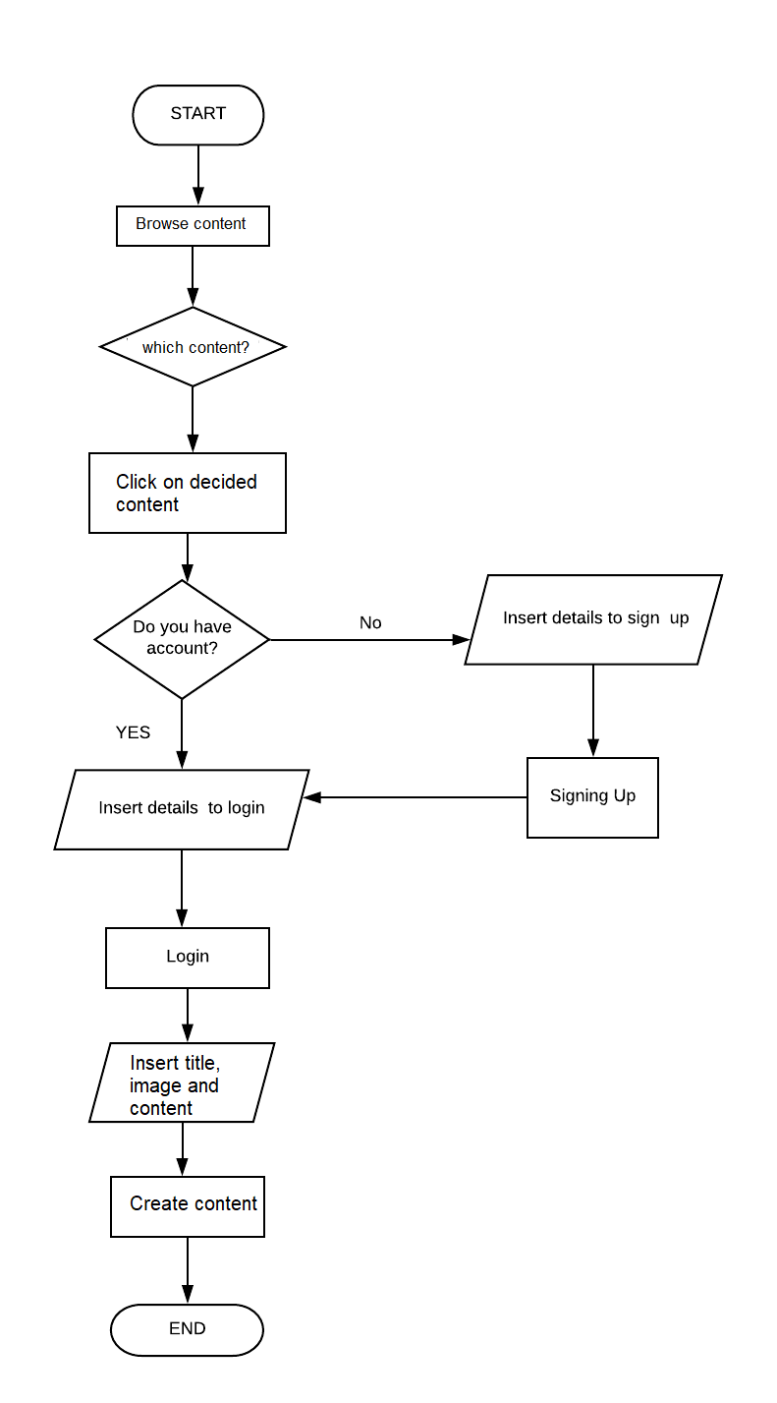

**Data Flow Diagram**

## 2.3 数据库设计

Database is explicitly created from personal design based on the websites functionality. I imagined a database for users, contents, categories and comments. For login function, it will check whether the username and password tally with one another in the user table. For browse function, it will fetch the data from the contents table. User may only create content based on the categories that is designed by me in the first place so that is where the category table comes in handy. In order for users to left a comment on individual contents, their comments will be stored in the comments table. The design and current data are in the screenshots below.

### 2.3.1 Database diagrams

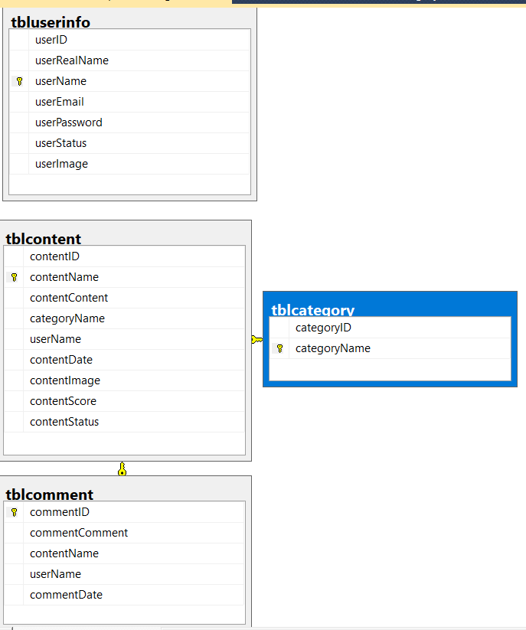

### 2.3.2 Design tab

#### 2.3.2.1 tblcategory

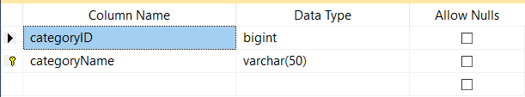

#### 2.3.2.2 tblcomment

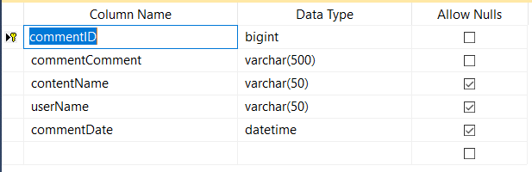

#### 2.3.2.3 tblcontent

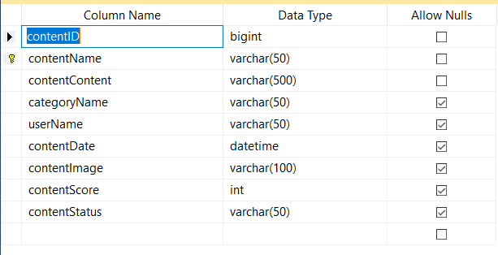

#### 2.3.2.4 tbluserinfo

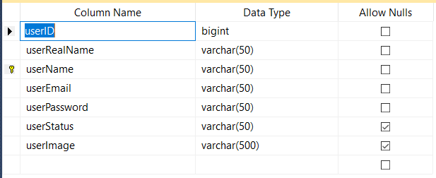

### 2.3.3 Edit top 200 row

#### 2.3.3.1 tblcategory

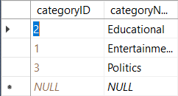

#### 2.3.3.2 tblcomment

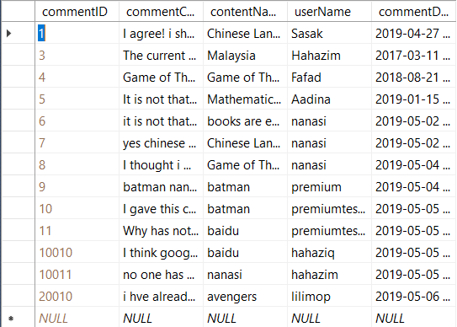

#### 2.3.3.3 tblcontent

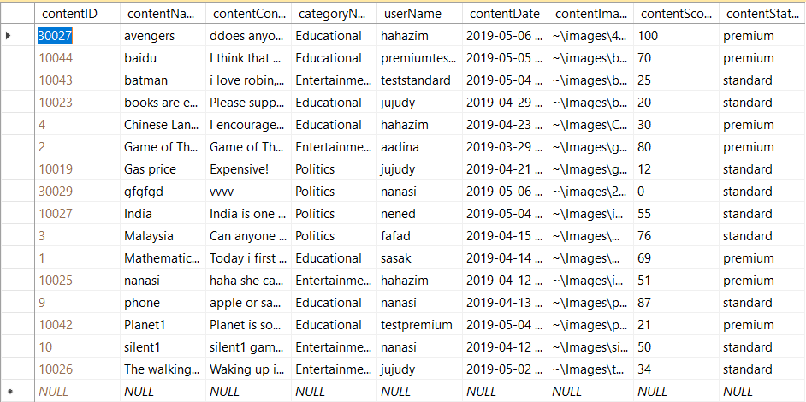

#### 2.3.3.4 tbluserinfo

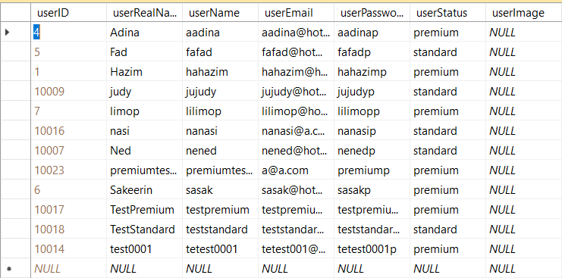

## 2.4 Program design of the website

### 2.4.1 No account

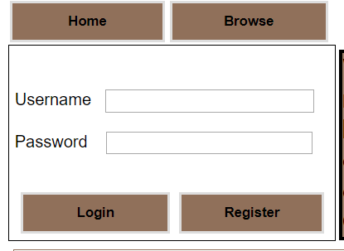

**Figure 1.0**

In this section, when users click the “Home” button. Users will be prompted back to this page (Default.aspx). The ”Browse” button will lead you to the (Browse.aspx) page where the whole content will be displayed EXCEPT for premium content created by premium users. The “Login” button will search the match between the userName and userPassword column in tbluserinfo. The values are inserted by the user in the Username and Password textboxes as shown in Figure 1.0. The “Register” button will lead you to (Register.aspx) page where you can register an account.

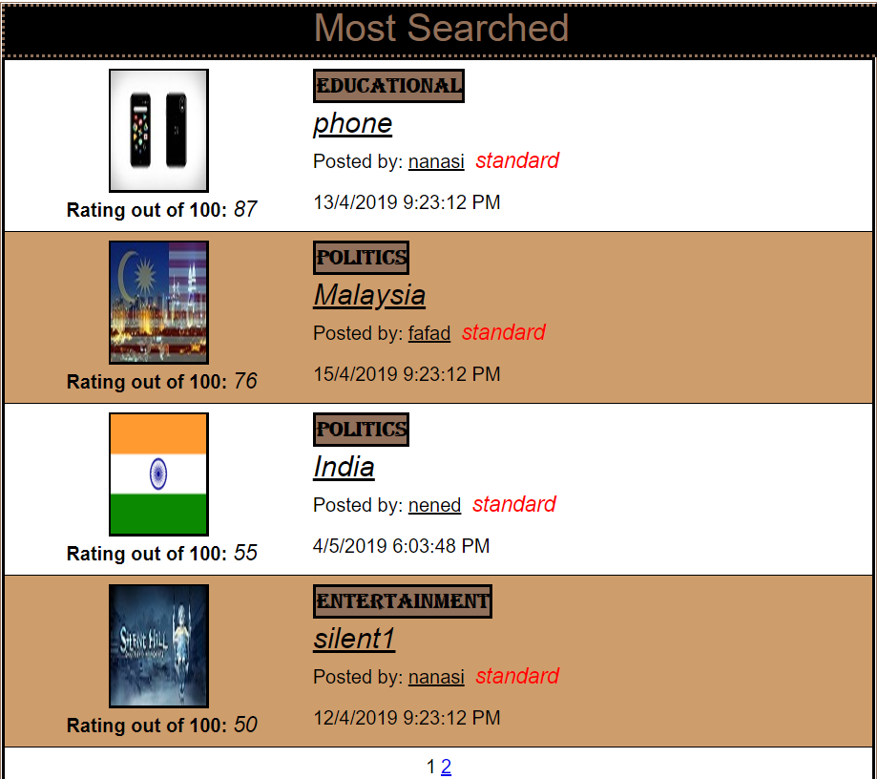

**Figure 1.1**

In this gridview, the data are listed in descending order based on the rating of the content. The rating of the content can be found in tblcontent under the contentScore column. The rating system will be explained later in its section. Each page will only display 4 rows.

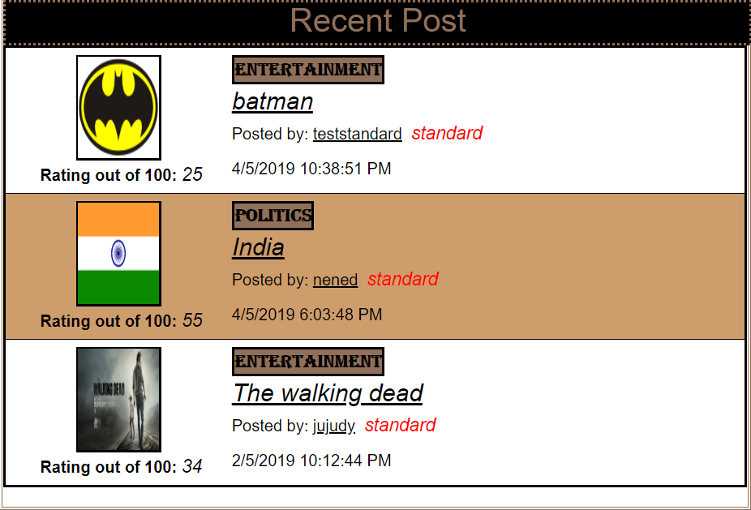

**Figure 1.2**

In this gridview, the data is shown in descending order based on he date it was posted. This gridview only shows the content that is created within 10 days from the date it was created.



**Figure 1.3**

This gridview shows the available category in tblcategory. As of now, only three categories are available as shown in Figure 1.3. Users are prompt to choose a category from the three choices when creating a content and it will redirect you to the (Browse.aspx) page where contents will displayed by category.

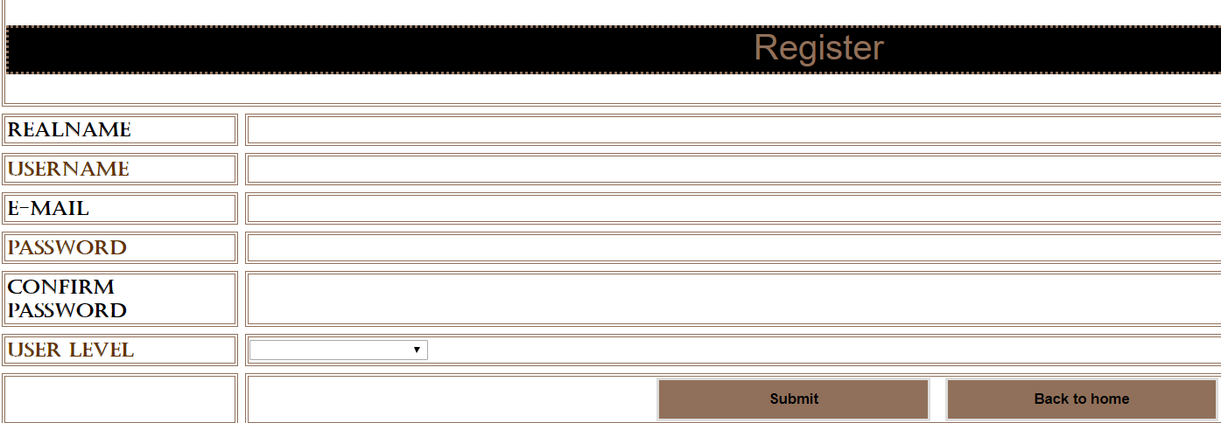

**Figure 1.4**

This is the register page. Users can register their Realname, Username, E-mail, Password and choose a level for their account. Realname does not play any important role. Username and password is what allows the user to login later on. Confirm password is to make sure the user inserted the password without error. User level is what distinguishes you from a premium user and a standard user. Basically speaking, a premium user can see all the contents where as the standard user only can see contents posted by other fellow standard level user. Upon clicking submit button, account will be created and if “Back to home” button is clicked, the registration is cancelled and you will be prompted back to the (Default.aspx) page.

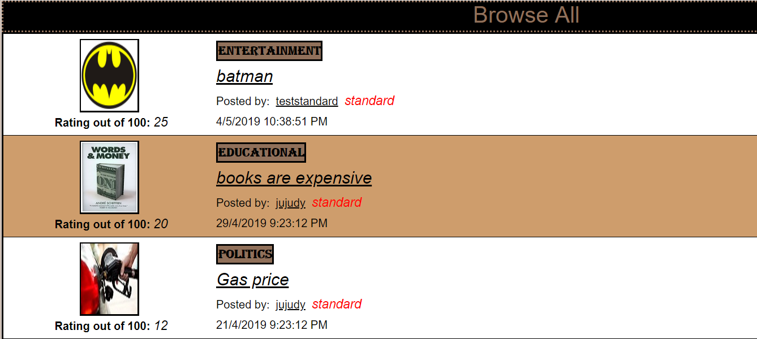  
**Figure 1.5**

When user clicked the browse button in (Default.aspx) page, user will be prompted to (Browse.aspx) where all the data (aside from premium) contents will be displayed.



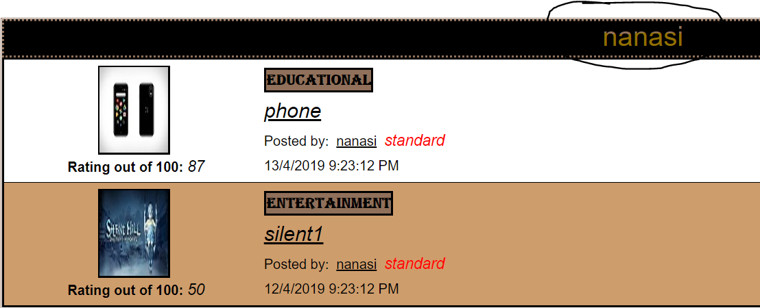

**Figure 1.6**

My search bar uses the “Fuzzy” search where you can search something partial from its real name and it will search for you the whole name (granted that you have no spelling error). My search will check keywords for username, contentname, categoryname, contentscore and contentstatus from tblcontent. Upon clicking the search button, the keyword will be brought to the (searchnotlogged.aspx) page. Based on Figure 1.6, we can see that they keyword is “nanasi” and everything related to “nanasi” will be appeared.



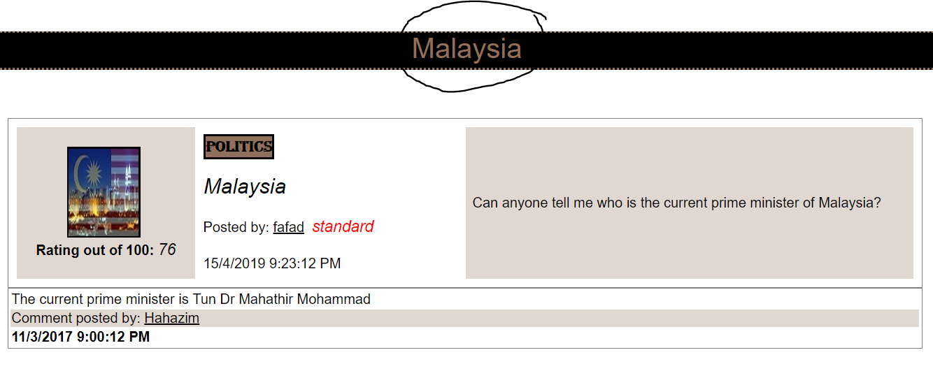

**Figure 1.7**

From this gridview, it is design using edit template. The name of the content is a hyperlink which upon clicking, it will open the (detailnotlogged.aspx) page. In Figure 1.7, if we use the “Malaysia” content name as an example. After clicking its name, in the other page, the content name will be displayed as shown and all its information is revealed. The content’s description will only appear in this page as well as comments posted specifically to that content.

### 2.4.2 Logged in



**Figure 2.0**

After successfully logged in, at the top, you have several buttons. Your username and account level or status will also be visible. When clicking “Home”, it will open for you the (Home.aspx) page where the contents are the same as when not logged in. However, the types of content displayed is based on your account status. The “Browse” button will open for you (Browselogged.aspx) page and also displaying content depending on your user level. The “Profile” button will open up (Profile.aspx) page where user can change their current password. The “Create” button will bring you to (Create.aspx) where you can start creating your content. “Update Content” button allows you to update existing content description if the poster wants to make any alterations. The logout button will prompt the user to logout and will open up the (Default.aspx) page.

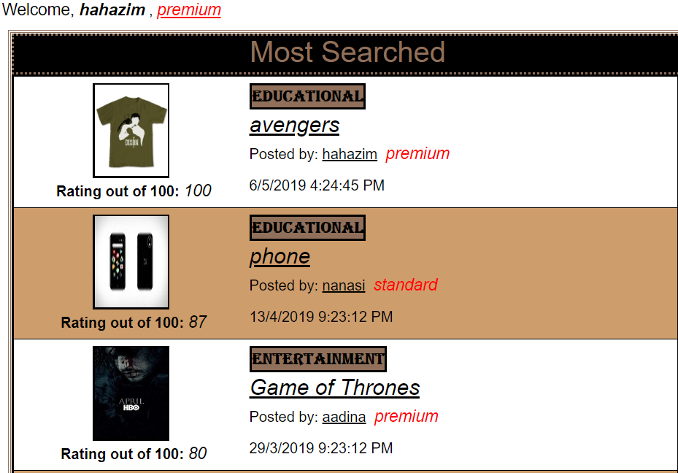

**Figure 2.1**

Based on Figure 2.1, a user goes by the username of “hahazim” has logged in with an account status of premium. As you can see under the “Most Searched” gridview, he is able to see premium content as well.

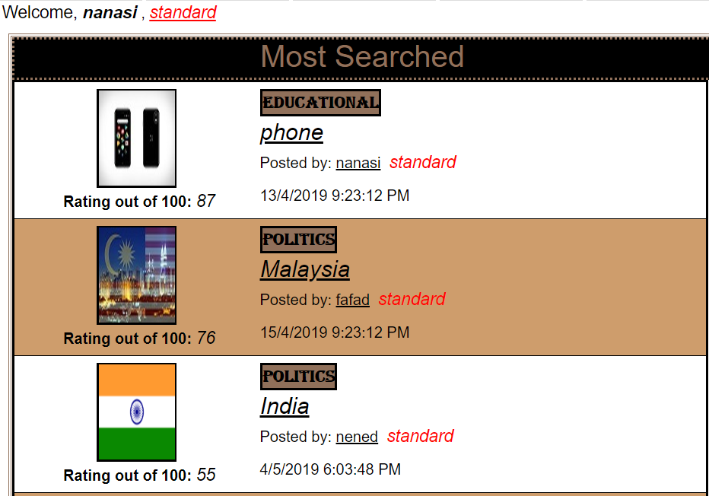

**Figure 2.2**

In Figure 2.2, a username “nanasi” has logged in with an account status of standard. As you can see in the “Most Searched” gridview, he is able to see only the standard-leveled content,

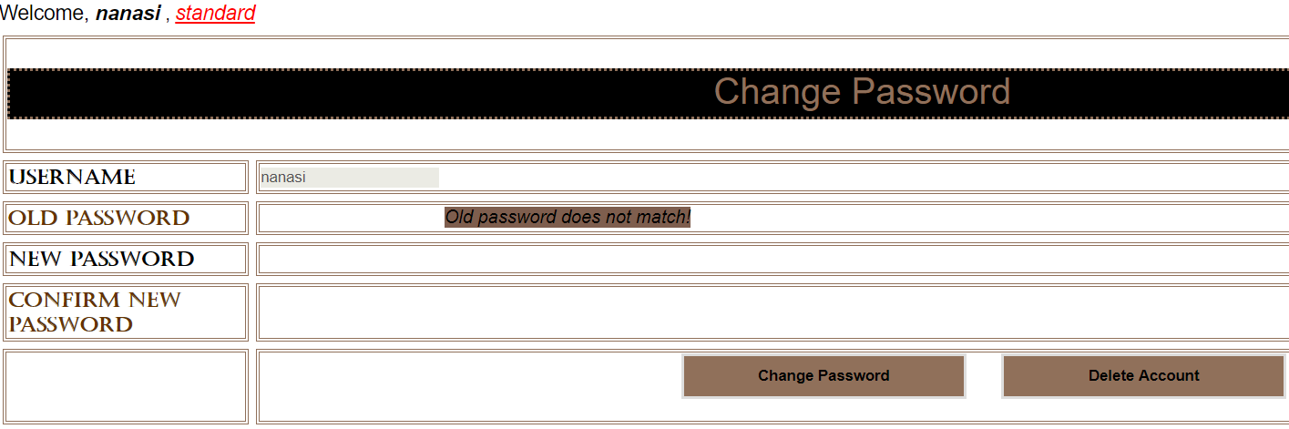

**Figure 2.3**

In the Profile page, username will be auto-filled. In order to change password, you need to insert the correct old password. After that, you can insert your new password that must be matched with the “Confirm new password” textbox. Subsequently, if you want to delete you account, you need to insert your old password correctly only you can successfully delete your account by clicking the “Delete Account” button,

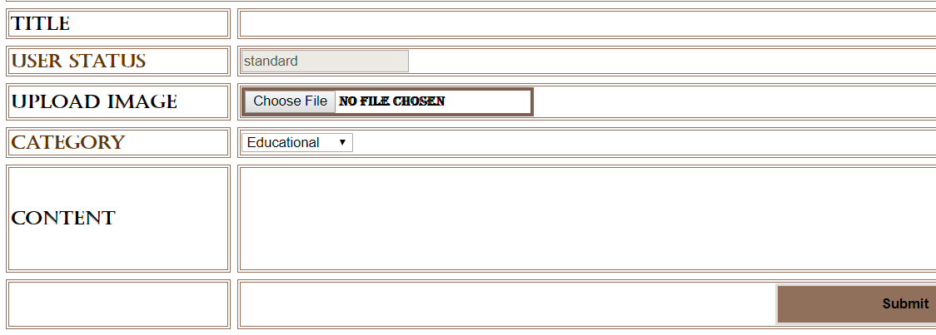

**Figure 2.4**

In the Create page, you can create your content by first inserting its Title. Userstatus is automatically filled. You may upload an image for your content if you wished. Select the category accordingly and begin writing you content. As the final step, just click on the “Submit” button and your content will be successfully created.

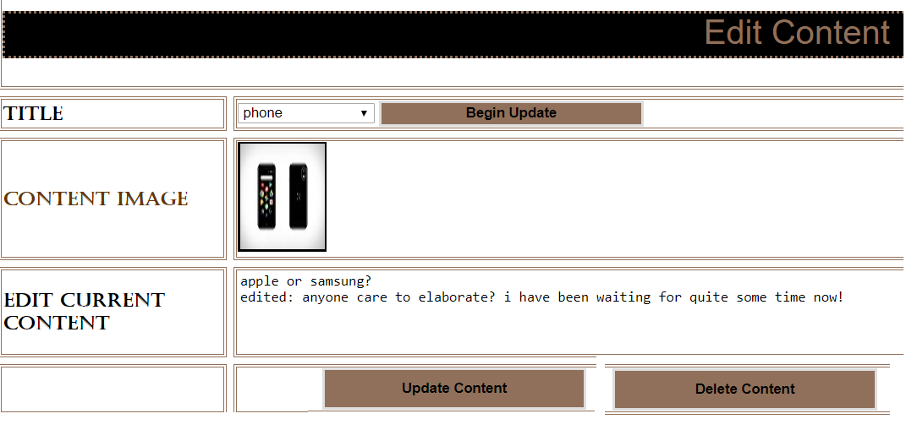

**Figure 2.5**

In the Edit Content page, if you have any content, it will appear in the title drop down list. Once selected, click the begin update button to fetch all the current data. Now, you may update your content as you please. Upon finish updating, click the “Update Content” button. If you wish to delete your content all together, you may click the “Delete Content” button and your content will immediately be deleted from the database.

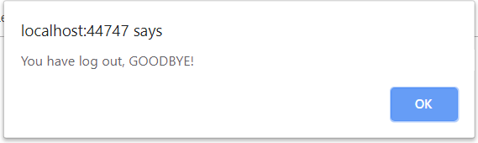

**Figure 2.6**

When you clicked the “Logout” button, Figure 2.6 message will appear and you will be thoroughly logged out and will be dragged back to the (Default.aspx) page.

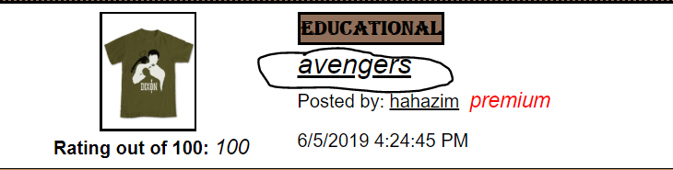

**Figure 2.7.1**

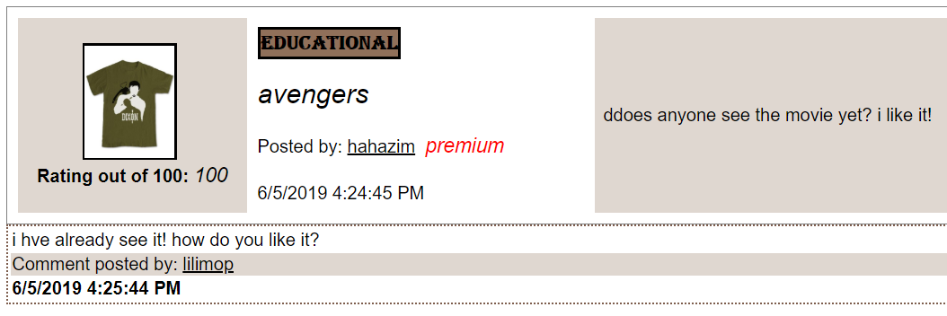

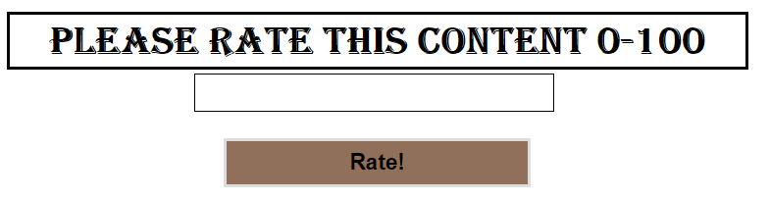

**Figure 2.7.2**

When you clicked on content’s name as shown in Figure 2,7.1, you will be launched to (searchlogged.aspx) page where the content details will appear. You may rate the content from 0 out of 100. Once you insert the number and click the “Rate!” button, the current rating will immediately be substitute by your new rate.



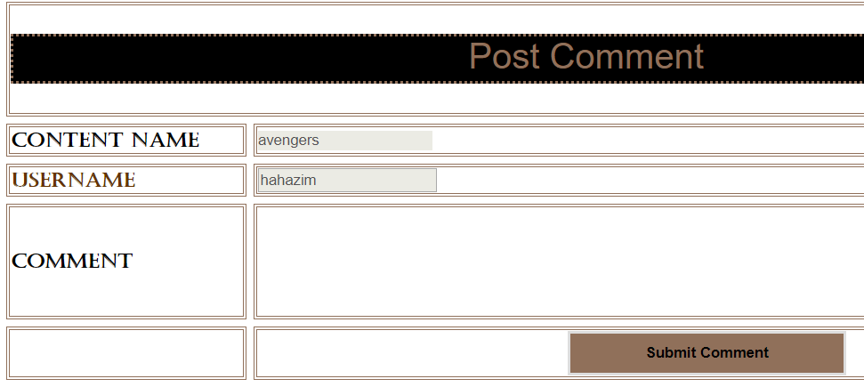

**Figure 2.8**

As shown in Figure 2.8, also in (detaillogged.aspx) page, you may leave a comment and thoughts about the post. The content name and username will be autofill based on your selection and personal information. After inserting some comments in the comment box, immediately click on the “Submit Comment” button and your comment will appear below the previous one.

## 2.5 系统测试

|  |  |  |  |  |  |  |  |
| --- | --- | --- | --- | --- | --- | --- | --- |
| **项目名称** | TalkNPost | | **程序版本** | V1.0 | | | |
| **编制人** | 何子铭 | | **编制时间** | 11周 | | | |
| **测试目的** | 确保数据库化网站的功能性 | | | | | | |
| **特殊规程说明** | | | | | 无 | | |
| **用例编号** | **输入数据/操作** | **预期结果** | | | **测试结果** | **缺陷编号** | **备注** |
| **Admin Panel** | | | | | | | |
| 1 | Login/Sign Up | The page prompt out in every non-logged page | | | The page prompt out in every non-logged page | 无 |  |
| 2 | 账号：hahazim  密码：hahazimp | Login success, Home.aspx appeared | | | Login success, Home.aspx appeared | 无 |  |
| 3 | Create content | New Destination will appear in database tblcontent | | | New Destination appear in database tblcontent | 无 |  |
| 4 | Edit content | The updated content will appear | | | The updated content appeared | 无 |  |
| 5 | Change password | Password change successful | | | Password change successful | 无 |  |
| 6 | Browse a category: educational | Browse.aspx appeared category educational | | | Browse.aspx appeared category educational | 无 |  |
| 7 | Search “nanasi” in search bar | “Nanasi” result appeared | | | “Nanasi” result appeared | 无 |  |
| 8 | Create a content | Appeared in most recent most top location | | | Appeared in most recent most top location | 无 |  |
| 9 | Rate a content “Malaysia” 76 | Rate score 76 will appear | | | Rate score 76 appeared | 无 |  |
| 10 | Register premium user | Premium tag will appear beside name after register | | | Premium tag appeared beside name after register | 无 |  |
| 11 | Update existing content description “avengers” to ddoes anyone see the movie yet? I like it! | Description will be updated | | | Description updated | 无 |  |
| 12 | Register standard user | standard tag will appear beside name after register | | | standard tag appeared beside name after register | 无 |  |
| 13 | Change Password in profile | Change password successful | | | Change password succeeded | 无 |  |
| **User Panel** | | | | | | | |
| 14 | Home | Home page display | | | Home page display | 无 |  |
| 15 | Browse as standard account | All standard level content appeared | | | All standard level content appeared | 无 |  |
| 16 | Browse as premium account | All content will appear | | | All content appeared | 无 |  |
| 17 | 账号：lutut  密码：lututp | Login will fail | | | Login failed | 无 |  |
|  |  |  | | |  |  |  |
| 18 | Log out | Log out back to Default.aspx | | | Logged out back to Default.aspx | 无 |  |
| 19 | Delete a content created | Content will be deleted | | | Content deleted | 无 |  |
| 20 | Post a comment on content “avengers” | Comment will be posted | | | Comment posted successfully | 无 |  |
| 21 | Delete an account without inserting password and insert wrongly | Delete account will fail | | | Account deletion failed | 无 |  |

# 

# Reflection

Doing this project has definitely increase my knowledge and skills on creating a fully functioning website. Who would’ve thought just with the help of ASP.NET, everything is possible. The control tools it provided definitely put my mind to ease when using them accordingly without worrying its functionality as everything has already been prepared. Not to mentioned that you have the cs page to do all the necessary coding. Furthermore you may even easily connect your SQL database with the help of datasource. All and all, I never thought it would be this simple. Eventhough when learning to do so consumes a lot of time and energy. But once the knowledge has align nicely in my train of thoughts, everything seems to be simple.

I will forever cherish the knowledge I learn and gained by studying here in China. I feel that when I am back in MSU, our course focused more on theory and less on hands-on. The importance of technical based studying has never been clearer to me. This knowledge not only helps me in my studying years, I feel that in my carrier in will prove to be immensely useful. I hope in the near future the systems I went through to get me to where I am today will be followed by my successor.

# 

# References

* <https://dict.naver.com/linedict/zhendict/#/cnen/search?query=%E9%9C%80%E6%B1%82%E5%88%86%E6%9E%90%20> (to translate languages)
* <https://fanyi.baidu.com/translate?aldtype=16047&query=%E6%88%91%E8%A2%AB%E7%AA%9D%E7%9A%84%E8%80%81%E6%9D%BF%E9%AA%82%E4%BA%86&keyfrom=baidu&smartresult=dict&lang=en2zh#zh/en/%E7%BD%91%E7%AB%99%E6%A6%82%E8%BF%B0>

(also to translate languages)

* <https://dotnet.microsoft.com/apps/aspnet>
* Youtube.com (to search any issue by watching tutorial video)